555 Extra Pulse Catcher (Lab Part 3)

Sept-2021

References: ‘*TECHIN512 Lab 555 Timer Lab*’

‘TECHIN 512 “The Emitter” Simplified Version’ test box. Because of online course structure, you need to build you own ‘Emitter’ box using an Arduino. Please check the folder ‘TheEmitterV1_5’

To build the circuit for detecting an extra pulse, added to a basic 1kHz train of 10 micro-sec, we need to solve the following problems (among others):

1. Provide timing and logic to look for the extra pulse while ignoring the basic 1kHz pulse train.
2. Trigger the 555 from a pulse which stays low for most of its duty cycle (a positive pulse of 5% duty cycle for example). We discovered that the constant low logic level after such a pulse keeps the monostable timer in “reset” state.
3. Generate a roughly 0.5-1.0 second pulse to drive a visible LED flash.

First, let’s solve problem 2). The key is our friend the RC circuit!. A “high pass” RC circuit can also be thought of as an “edge trigger.” An edge trigger is a circuit which outputs a really quick pulse when an input signal changes state. This way the 555 will trigger on the (falling) edge of its input pulse, but NOT be held in reset by a subsequent low level. When the input pulse changes rapidly from 0 -> 1, the capacitor current spikes positive (which can be ignored by the 555) but when it drops, the capacitor current goes negative and we get a negative glitch (which is good to trigger the 555). **Please notice that Vcc should be 4.5V instead of 5V.**

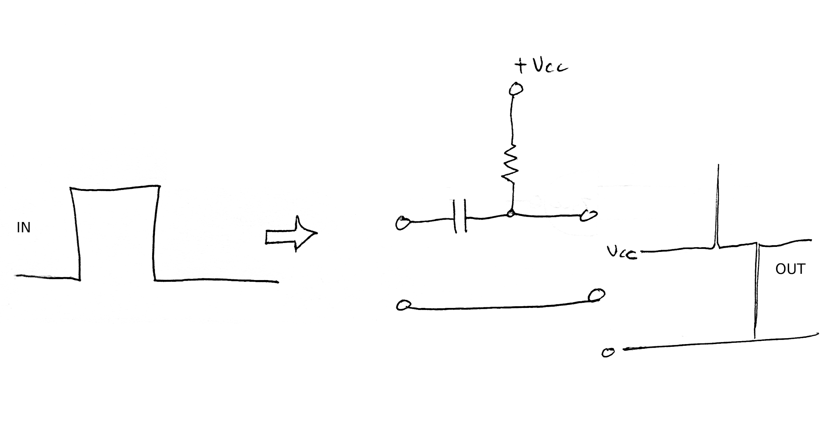

In the schematic below,

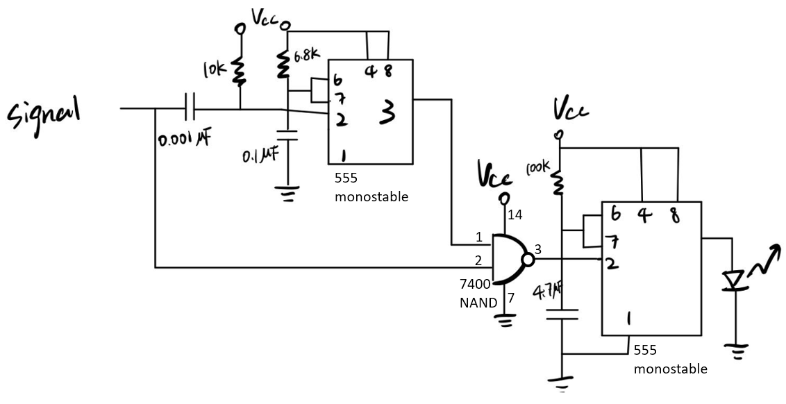

(circuit diagram from Robin Yang, UW GIX cohort 3)

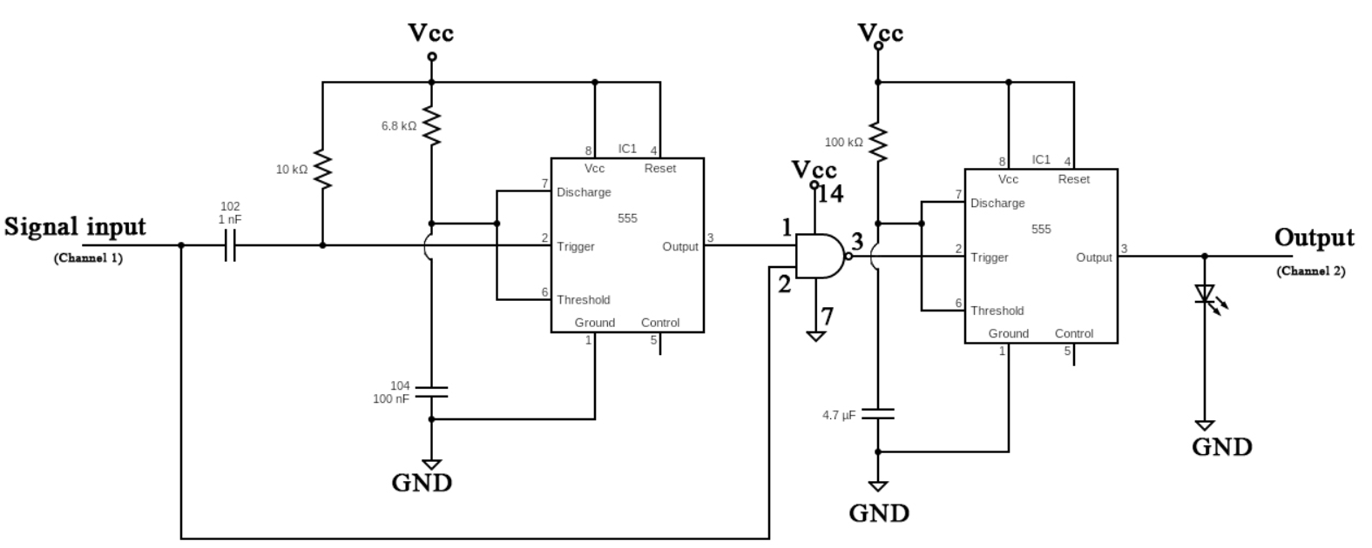

(circuit diagram from Yue Yu, UW GIX cohort 4)

We have such an edge trigger on the input to a 555 monostable. Triggered by the edge-trigger, the 555 generates a pulse about 800 u sec long (to indicate most of the correct pulse-catching interval). Set the R and C values for this 555 for 750-950 u sec. Then if the input pulse is high AND we are in the 800 u sec interval between regular pulses, we have caught a glitch. The NAND gate output will go LOW at that point, triggering another 555 to make a visible pulse on an LED (probably 0.5 sec is better than 1.0 sec delay to match the LED on The Emitter). (Notes, You may have to play around with RC values to get this to work (values above worked). if your circuit has a glitch on the NAND gate output, try putting a capacitor between +Vcc and Ground).

A working circuit and screen shot are shown below.

